Reports
In JReview Template reports are stored under several main folders:

Administrative folder 3
All Table Columns 3
Study by PI Report 4
Study Data Date Report 4
CR Reports folder 5
CR AE/SAE Count Report 5
CR Report – CTCAE V5 (V4) 5
IRB-Reports folder 6
AE Summary – FDA – Double IND Report 6
AE Summary – FDA – Single IND Report 7
Labs folder 7
Lab Datalisting + Course Num/Day – Single Panel 7
Lab Datalisting – Days Post Transplant (Transplant Study Only) 8
Template Reports folder 9
Adverse Events Data Listing Report (CTCAE V5 or V4) 9
AE Data Listing Report (CTCAE V5 or V4) 10
Arm and Cohort Assignment Report 11
Baseline Medical History Report 12
Baseline Symptom Report (CTCAE 5.0 or 4.0) 13
Concomitant Measure/Medications Report 14
Demographics Report 14
Enrollment Report 15
Extent of Disease Report 15
Follow Up Report 16
Off Study Report 17
Off Therapy (Treatment) Report 17
Off Treatment/Off Study Report 18
Prior Therapy Supplement Report 18
Study Drug Administration Report 19
Study Drug Administration/Missed Combined Report 20
Subject Enrollment Report 20
Subject Info Report 21
Survival Report 21
Unreviewed Manual Labs Report – Filtered 22

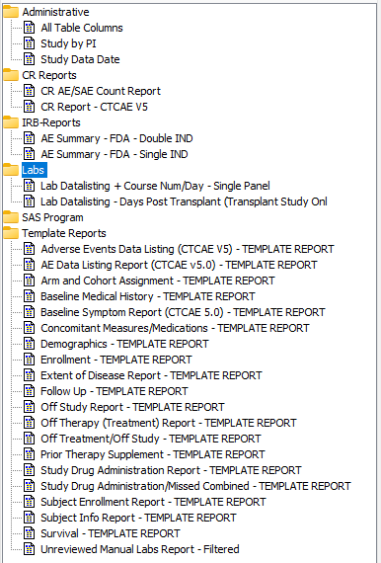
Many of the reports accept parameters including cutoff dates and Grade
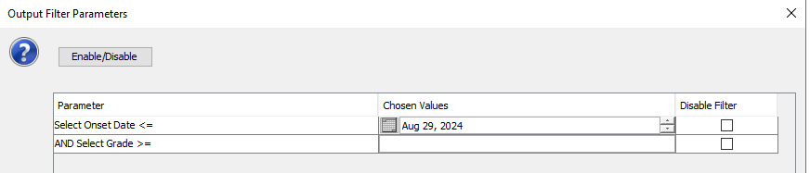

Administrative folder

All Table Columns
All Table Columns report shows the fields, field type, field length and field label in each form of a study. This report accepts one parameter: Form.
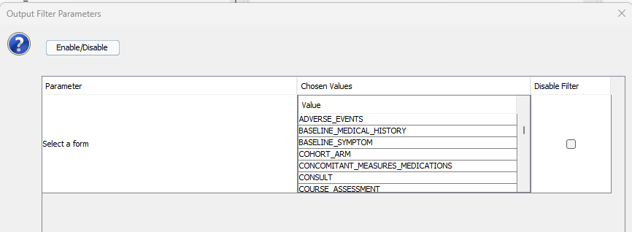
Below is a sample report, report has the following columns:
- Form
- Field
- Type
- Length
- Label
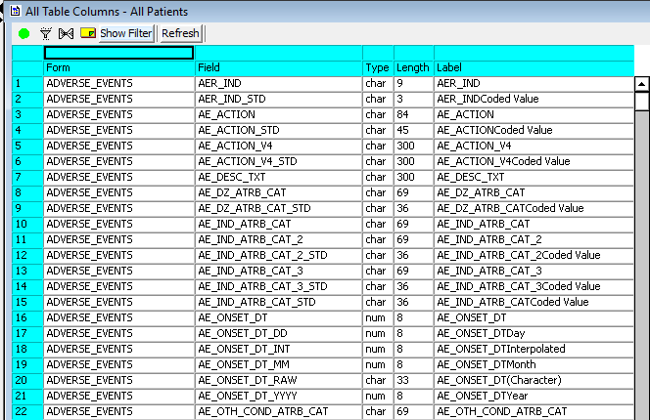

Study by PI Report
Study by PI Report shows the study folder (PI) each project is associated with.
Below is a sample report, report has the following columns:
- STUDYID
- PROJECT
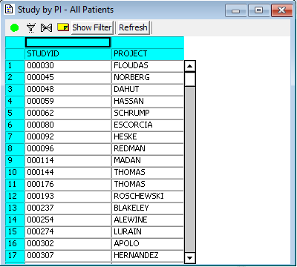

Study Data Date Report
Study Data Date report lists out the as of date of each study. This shows the last refreshed date of the study. If no data change is being done, the study data date will not be updated.
Below is a sample report, report has the following columns:
- Data_date
- STUDYID
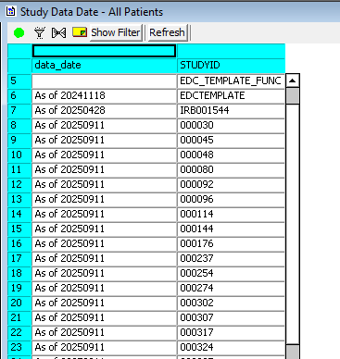

CR Reports folder

CR AE/SAE Count Report
CR AE/SAE shows the total number of all Adverse Events and the total number of Serious Adverse Events collected in the Adverse Event form in the study.
Below is a sample report, report has the following columns:
- # of AEs (AE Count)
- # of Serious AEs (SAE Count)
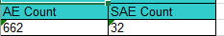

CR Report – CTCAE V5 (V4)
CR Report shows the number of events related to Research since Last CR Reporting and # of Events related to Research since Study Start, which are grouped by grouped by SOC, CTCAE Term, AE Description, Grade, Attribution to Research, Serious, Unexpected. It requires two parameters to be entered: Previous Cutoff Date and Current Cutoff Date.
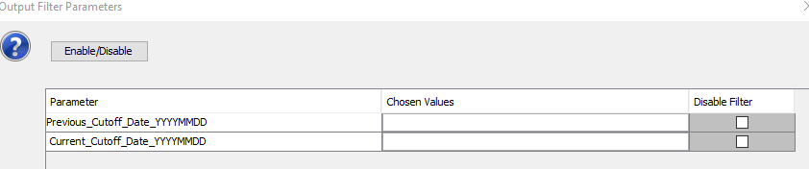
Below is a sample report, report has the following columns:
- Study
- SOC
- AE Term
- Description
- Grade
- Unexpected
- Serious
- # Events Since Last Report
- # Events Since Study Start
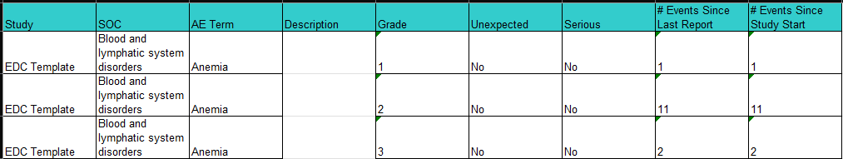

IRB-Reports folder

AE Summary – FDA – Double IND Report
AE Summary – FDA – Double IND Report shows the total number of Adverse Events prior to the provided onset date for studies with double INDs. It is grouped by Study, SOC, CTCAE Term, AE Description, Grade, Attribution to IND1, Attribution to IND2 and Serious. It accepts two parameters, Onset Date and Grade.
Below is a sample report, report has following columns:
- Study
- SOC
- CTCAE Term
- Adverse Event Description
- Grade
- # of Adverse Events
- Attribution to IND1
- Attribution to IND2
- Serious.
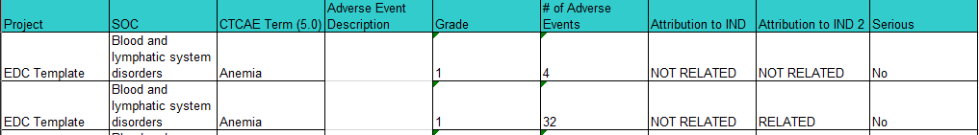

AE Summary – FDA – Single IND Report
AE Summary – FDA – Single IND Report shows the number of Adverse Events prior to the provided onset date for studies with single IND. It is grouped by Study, SOC, CTCAE Term, AE Description, Grade, Attribution to IND and Serious. It accepts two parameters, Onset Date and Grade.
Below is a sample report, report has following columns:
- Study
- SOC
- CTCAE Term
- Adverse Event Description
- Grade
- # of Adverse Events
- Attribution to IND
- Serious
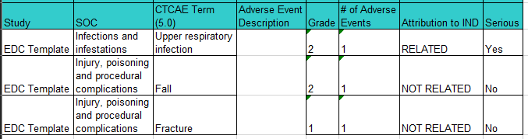

Labs folder

Lab Datalisting + Course Num/Day – Single Panel
Lab Datalisting + Course Num/Day lists out all labs and derives the course information in the report. This report is only for single lab panel studies.
Below is a sample report, report has following columns:
- Study
- Site
- Subject
- Record_position
- Source_Lab_Data
- Lab_Date
- Lab_Time
- Course_Num
- Course_Day
- Lab_Test
- Lab_Val_Char
- UOM
- Preferred_UOM
- Norm_Range
- Grade
- Comments_Date
- Comments
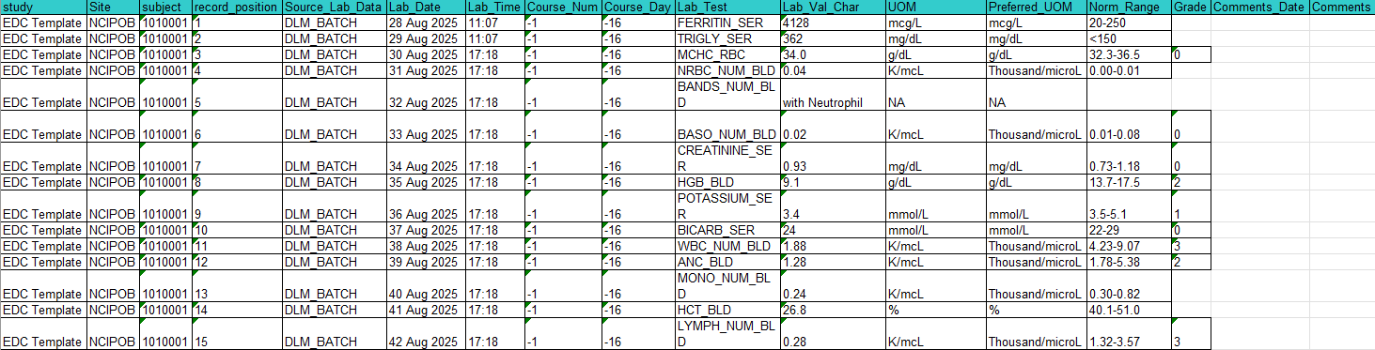

Lab Datalisting – Days Post Transplant (Transplant Study Only)
Lab Datalisting – Days Post Transplant (Transplant Study Only) lists out all labs and derives the days post-transplant. This report is only for transplant studies that have only single lab panel.
Below is a sample report, report has following columns:
- Study
- Subject
- Source of the Lab Data
- Lab Date
- Lab Time
- Days Post Transplant
- Lab Test
- Lab Value (Char)
- UOM
- Preferred UOM
- Normal Range
- Grade
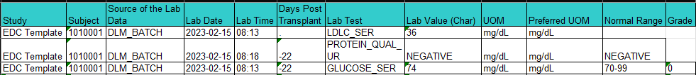

Template Reports folder

Adverse Events Data Listing Report (CTCAE V5 or V4)
Adverse Events Data Listing Report lists out all columns in Adverse Event form. All active data will be included in the report. It accepts two parameters: Subject and Current cutoff date.
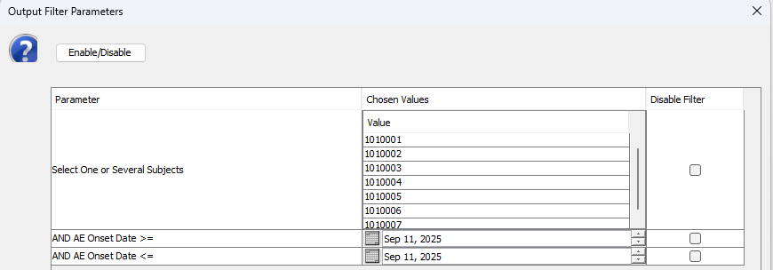
Below is a sample report, report has the following columns:
- Study
- Site
- Subject
- Date of Onset
- Date of Resolved
- CTCAE Term (5.0)
- SOC
- Adverse Event Description
- Grade
- Grade (Coded Value)
- Attribution to Research
- Attribution to IND
- Attribution to IDE
- Attribution to Commercial
- Attribution to Radiation
- Attribution to Surgery
- Attribution to Disease
- Attribution to Other
- Other Specify
- Is the AE Immune Related?
- Unexpected AE
- AESI
- Serious
- Death
- Hospitalization, Prolonged Hospitalization
- Life-threatening
- Persistent or significant or substantial disruption of the ability to conduct normal life functions
- Congenital anomaly/birth defect
- Important Medical Event
- Action
- Therapy
- Outcome
- Expedited Report to IRB
- Expedited Report to Sponsor
- Comments
(cont.)

AE Data Listing Report (CTCAE V5 or V4)
AE Data Listing Report lists some common fields in Adverse Event form. This report accepts two parameters: Subjects and Current Cutoff Date.
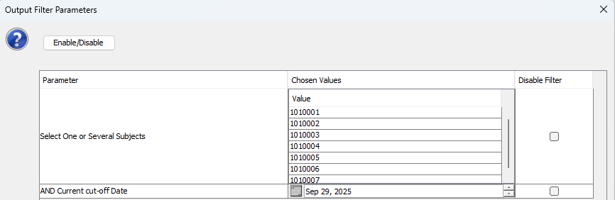
Below is a sample report, report has the following columns:
- Study
- Site
- Subject
- Date of Onset
- Date Resolved
- CTCAE Term (5.0)
- Adverse Events Description
- Grade
- Grade (Coded Value)
- Attribution to Research
- Attribution to IND
- Attribution to Disease
- Attribution to Other
- Other, specify
- Unexpected AE
- Therapy
- Expedited Report to IRB

Arm and Cohort Assignment Report
Armand Cohort Assignment Report shows the Arm and cohort information of all subjects in the study.
Below is a sample report, report has the following columns:
- Study
- Site
- Subject
- Log Line
- Date
- Cohort Name
- Cohort Description
- Arm Name
- Arm Description
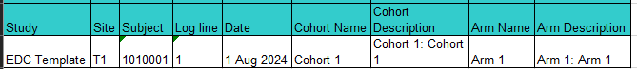

Baseline Medical History Report
Baseline Medical History Report shows all columns in Baseline Medical History form. All active data will be included in the report. This report accepts one parameter: Subject.
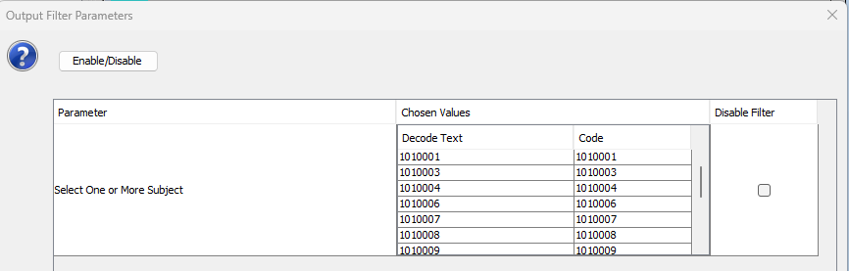
Below is a sample report, report has the following columns:
- Study
- Subject
- Date of Examination
- Row #
- Body System
- Finding Results
- Medical History if Abnormal
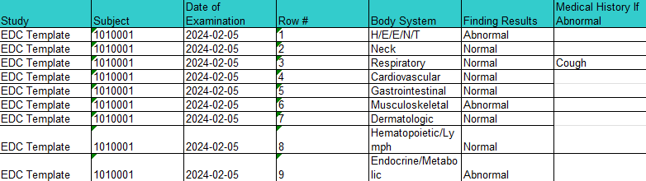

Baseline Symptom Report (CTCAE 5.0 or 4.0)
Baseline Symptom Report shows all columns in Baseline Symptom form. All active data will be included in the report. This report accepts one parameter: Subject.
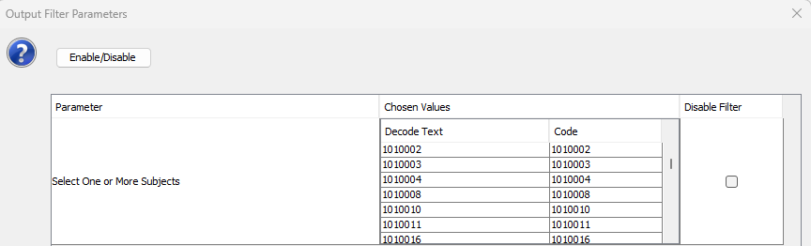
Below is a sample report, report has the following columns:
- Clinical Study
- Site
- Subject
- Onset Date
- Date Resolved
- CTCAE Term
- SOC
- Symptom Description
- Grade
- Related to Disease
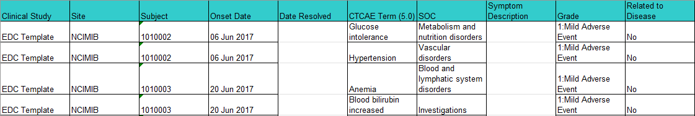

Concomitant Measure/Medications Report
Concomitant Measure/Medications Report shows all columns in the Concomitant Measure/Medications form. All active data will be included in the report.
Below is a sample report, report has the following columns:
- Study
- Site
- Subject
- Course #
- Day in Course
- Start Date
- Stop Date
- Agent Name
- Procedure/Measure
- Dose
- UOM
- Schedule
- Route
- Reason
- Comment
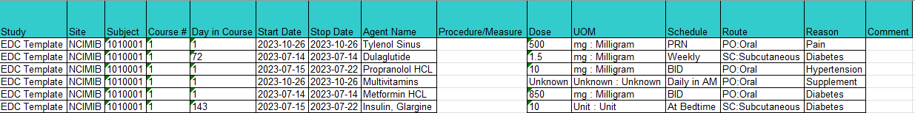

Demographics Report
Demographics Report shows the demographics data for all subjects in the study.
Below is a sample report, report has the following columns:
- Study
- Subject
- Date of Birth
- Age at Entry
- Patient Initials
- Sex
- Race
- Ethnicity
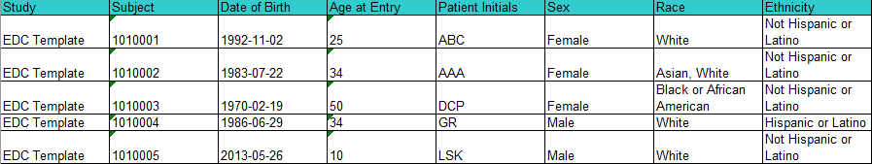

Enrollment Report
Enrollment Report shows all columns in the Enrollment form. All active data will be included in the report.
Below is a sample report, report has the following columns:
- Study
- Site
- Subject
- Lesion anatomic site description
- Date of Diagnosis
- Histology
- Grade of Histology
- Dose Level
- Disease stage at entry
- Gleason Score
- T Stage
- N Stage
- M Stage
- Date of Confirmation Histology
- Date of Informed Consent Version
- Date from which to start including labs
- Collected?
- Collection Date
- Comments

Extent of Disease Report
Extent of Disease Report shows columns from Extent of Disease Lesion Identification and Lesion Measurement forms. All active data will be included in the report.
Below is a sample report, report has the following columns:
- Study
- Subject
- Lesions #
- Anatomic Site
- Description of Location
- Description of Lesion
- Previously Irradiated
- Course #
- Day in Course
- Date of Evaluation
- How Measured
- Measurement (First Longest)
- Measurement (Second Longest)
- Measurement (Third Longest)
- Product
- Total Tumor Volume
- Eval #
- Eval Code

Follow Up Report
Follow Up report shows all columns in the Follow Up form. All active data will be included in the report.
Below is a sample report, report has the following columns:
- Study
- Subject
- Visit
- Date of Last Contact
- Type of Contact
- Explain – Other Type of Contact
- Received Treatment Since Last Contact?
- Subject Status
- Explain ‘Unknown’ Subject Status
- Response
- Response Date

Off Study Report
Off Study Report shows all columns in the Off Study form. All active data will be included in the report.
Below is a sample report, report has the following columns:
- Subject Name
- Folder Name
- Date Off Study
- Reason Off Study
- Reason Off Study Code
- Reason Off Study (Other)
- Date of Disease Progression
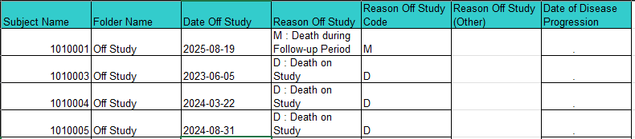

Off Therapy (Treatment) Report
Off Therapy (Treatment) Report shows the reason off therapy (or off treatment) and the date information in the Off Therapy form such as date off therapy, date last medication administration and etc.
Below is a sample report, report has the following columns:
- Subject
- Date Off Therapy
- Reason Off Therapy
- Explain ‘Other’ Reason Off Therapy
- Date of Last Medication Administration
- Date of Best Response
- Best Response to Treatment
- Date of Disease Progression
- Date of Notes
- Notes
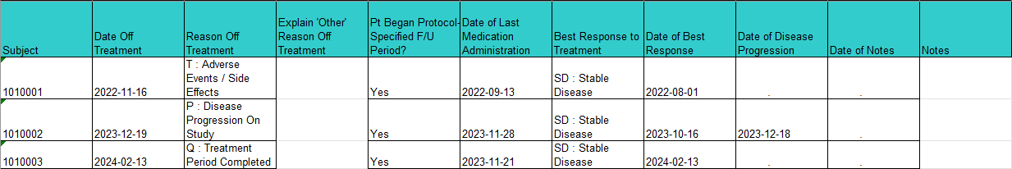

Off Treatment/Off Study Report
Off Treatment/Off Study Report shows the Off Treatment/Off Study Date and Reason and other information collected in the two forms.
Below is a sample report, report has the following columns:
- Study
- Subject
- Date Off Treatment
- Reason Off Treatment
- Explain ‘Other’ Reason Off Treatment
- Date of Last Medication Administration
- Best Response to Treatment
- Date of Best Response
- Date of Disease Progression
- Date Off Study
- Reason Off Study
- Explain ‘Other’ Reason
- Date of Disease Progression
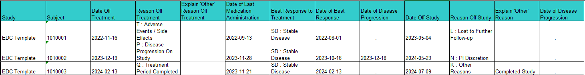

Prior Therapy Supplement Report
Prior Therapy Supplement Report shows all columns in the Prior Therapy Supplement form. All active data will be included in the report.
Below is a sample report, report has the following columns:
- Study
- Subject
- Record number
- Date of First Dose
- Date of Last Dose
- Agent Name
- Total Num of Courses Administered
- Therapy Type
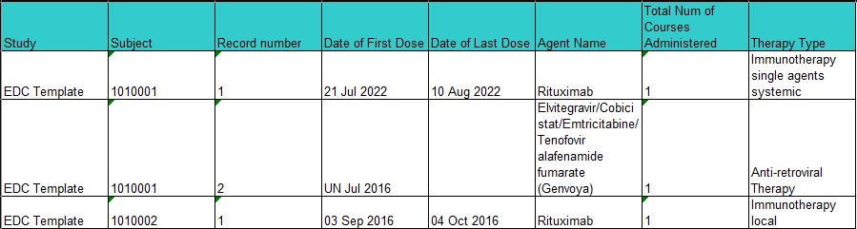

Study Drug Administration Report
Study Drug Administration Report is developed for studies that were migrated from C3D, which study drug administration and study drug missed are built in separate forms. This report shows patient initials and all columns in the Study Med Admin form. All active data will be included in the report.
Below is a sample report, report has the following columns:
- Study
- Subject
- Visit
- Day in Course
- Start Date
- Start Time
- Stop Date
- Stop Time
- Medication
- Dose Level
- Dose UOM
- Schedule
- Route
- Actual Dose
- Actual UOM
- Duration
- Duration UOM

Study Drug Administration/Missed Combined Report
Study Drug Administration/Missed Combined Report is developed for studies that have study drug administration and study drug missed combined in one form. This report shows patient initials and all columns in the Study Med Admin/Missed form. All active data will be included in the report.
Below is a sample report, report has the following columns:
- Study
- Subject
- Administered, Yes/No?
- Day in Course
- Start Date
- Start Time
- Stop Date
- Stop Time
- Medication
- Reason for Missed Dose
- Explain Other Reason
- Total Missed Dose Amount
- Missed Dose UOM
- Actual Total Dose
- Actual Dose UOM
- Route
- Lot #
- Duration
- Duration UOM

Subject Enrollment Report
Subject Enrollment Report shows all columns in the Subject Enrollment form. All active data will be included in the report.
Below is a sample report, report has the following columns:
- Study
- Subject
- Is the subject eligible?
- Date of Birth
- Age at entry
- Subject’s Initials
- Race
- Ethnicity
- Disease Term
- Registering Institute
- Registering Institute Description
- Date Informed Consent Signed
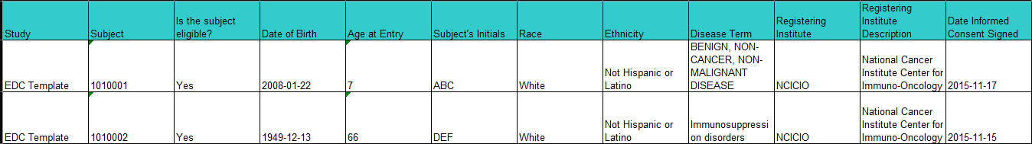

Subject Info Report
Subject Info Report includes information about disease, informed consent date and date start including labs.
Below is a sample report, report has the following columns:
- Subject
- Gender
- Date of Birth
- Disease Term
- Date of Diagnosis
- Date Informed Consent Signed
- Date from which to start including labs
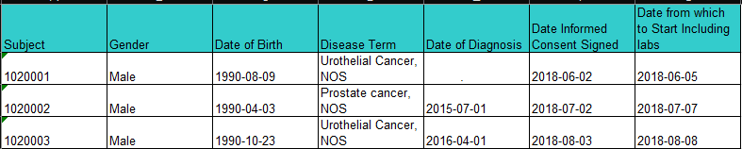

Survival Report
Survival Report shows all columns in the Survival form. All active data will be included in the report.
Below is a sample report, report has the following columns:
- Study
- Subject
- Date of Death
- Cause of Death (Presumed)
- Cause of Death Coded Value
- Explain ‘Other’ Cause of Death (Presumed) or CoMorbid Event, Specify
- Was Autopsy Done?
- Autopsy Results Available?
- Cause of Death (Autopsy-determined)
- Explain ‘Other’ Cause of Death (Autopsy-determined) or CoMorbid Event, Specify
- PI Reported Primary Cause Leading to Death
- Sites of Disease at Autopsy
- Comment
- Comment Date
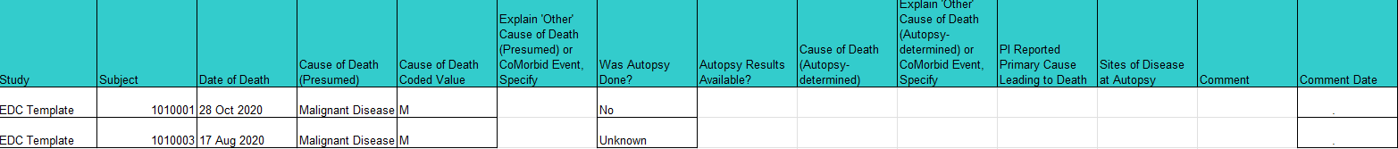

Unreviewed Manual Labs Report – Filtered
Unreviewed Manual Labs Report shows the study team review status of all manually entered labs. Labs loaded from C2L2 are not included in this report. Additionally, the report includes a parameter that allows the user to filter the 'Study Team Review' column to only view either reviewed ('Yes') or unreviewed ('No') data.
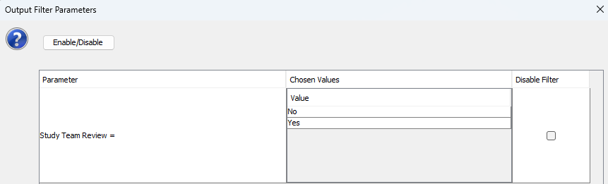
Below is a sample report, report has the following columns:
- Study
- Study_Site
- Subject
- Lab_Panel
- Lab_Source
- Lab_Date
- Lab_Time
- Course_Num
- Course_Day
- Study_Team_Review
- Lab_Test
- Lab_Value
- UOM
- Preferred_UOM
- Normal_Range
- Grade
