Reports
In JReview Template reports are stored under several main folders:
- Administrative folder
- Study by PI Report
- IRB-Reports folder
  - AE Summary – FDA – Double IND Report
  - AE Summary – FDA – Single IND Report
- Labs folder
  - Labs Report
  - Labs Received Report
  - NCI Lab Cluster Mapping
  - Processed Labs with CRIS Names
- Study Specific Reports folder
  - CR AE/SAE Count Report
  - CR Report
- Template Reports folder
  - AE Data Listing Report
  - Arm and Cohort Assignment Report
  - Baseline Symptom Report
  - Enrollment Report
  - Follow Up Report
  - Off Treatment/Off Study Report
  - Subject Enrollment Report
  - Course Summary Plus RECIST Report
  - Extent of Disease Report
  - Study Drug Administration Report
  - Study Drug Administration/Missed Combined Report (to be developed)
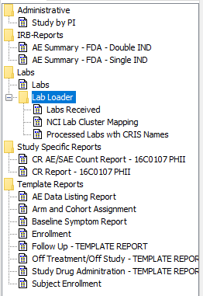
Many of the reports accept parameters including cutoff dates and Grade
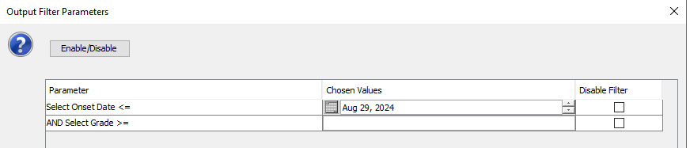
Administrative folder
Study by PI Report
Study by PI Report shows the study folder (PI) each project is associated with.
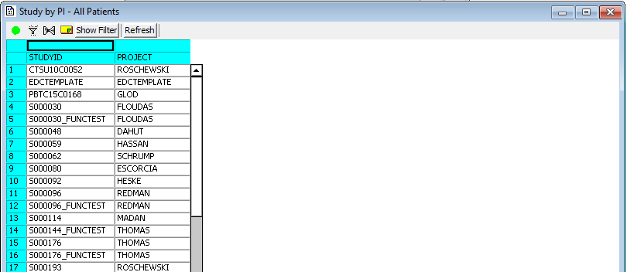

IRB-Reports folder
AE Summary – FDA – Double IND Report
AE Summary – FDA – Double IND Report shows the total number of Adverse Events prior to the provided onset date for studies with double INDs. It is grouped by Study, SOC, CTCAE Term, AE Description, Grade, Attribution to IND1, Attribution to IND2 and Serious. It accepts two parameters, Onset Date and Grade.
Below is a sample report, report has following columns:
- Study
- SOC
- CTCAE Term
- Adverse Event Description
- Grade
- # of Adverse Events
- Attribution to IND1
- Attribution to IND2
- Serious.
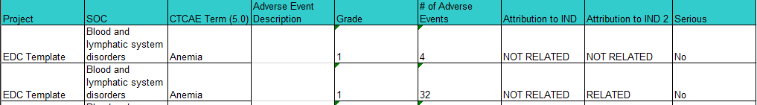

AE Summary – FDA – Single IND Report
AE Summary – FDA – Single IND Report shows the number of Adverse Events prior to the provided onset date for studies with single IND. It is grouped by Study, SOC, CTCAE Term, AE Description, Grade, Attribution to IND and Serious. It accepts two parameters, Onset Date and Grade.
Below is a sample report, report has following columns:
- Study
- SOC
- CTCAE Term
- Adverse Event Description
- Grade
- # of Adverse Events
- Attribution to IND
- Serious
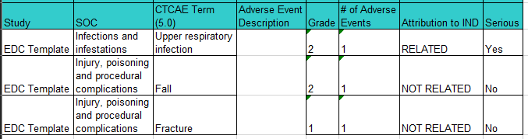

Labs folder
Labs Report
Labs Report is only available for studies which lab data is collected in one single laboratory form. It accepts three parameters: Lab Date From, Lab Date To, Lab Test Name.
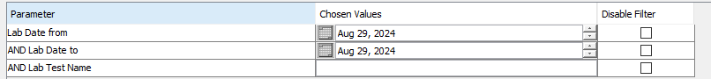
Below is a sample report, report has the following columns:
- Study
- Subject
- Source of the Lab Data
- Lab Date
- Lab Date (Character)
- Lab Time
- Lab Test
- Lab Value (Char)
- UOM
- Normal Range
- Grade
- Preferred UOM
- Comments Date
- Comments Note

Labs Received Report
Labs Received Report shows the status of all the labs Rave received from lab loader. It accepts multiple parameters as shown in the screenshot below.
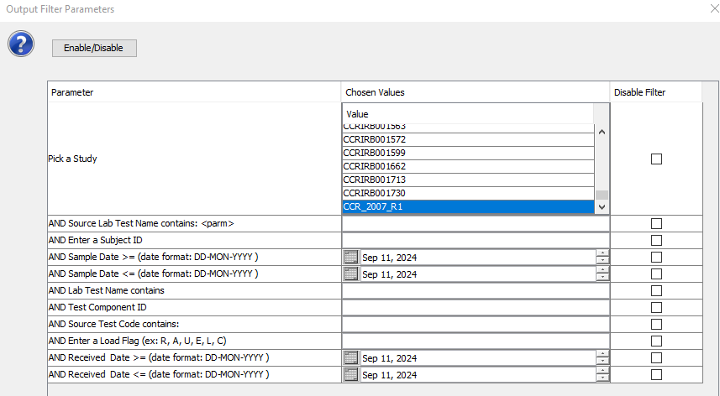
Below is a sample report, report has the following columns:
- Subject ID
- Source Test Code
- Test Component ID
- Sample Date Time
- Same Date
- Sample Time
- Lab Test Name
- Source Lab Test Name
- Source Lab Result
- Source Lab Unit
- Source Normal Range
- Received Date
- Error Reason
- Load Flag
- Lab Visit
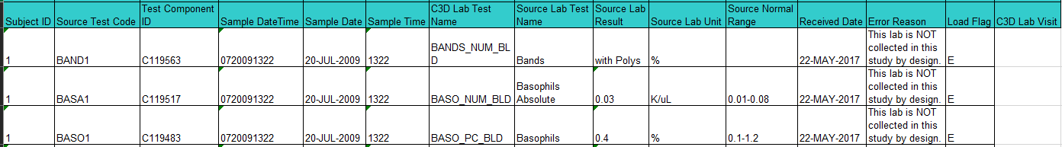

NCI Lab Cluster Mapping
The NCI Lab Cluster Mapping report shows how the lab test names in Rave are mapped to the actual lab tests and test components.
Below is a sample report, report has the following columns:
- OC_LAB_QUESTION
- MAP_VERSION
- LABORATORY
- TEST_COMPONENT_ID
- TEST_COMPONENT_NAME
- LAB_TEST
- MAPPING_TYPE
- DATE_CREATED
- DATE_MODIFIED
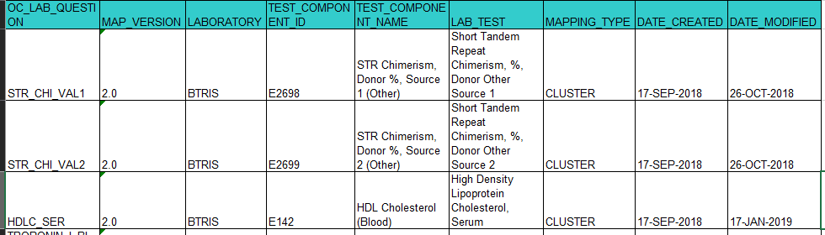

Processed Labs with CRIS Names
Processed Labs with CRIS name report shows the status of all the labs Rave received from lab loader with CRIS name and test code. This report accepts two filters: Study and OC_LAB_QUETION
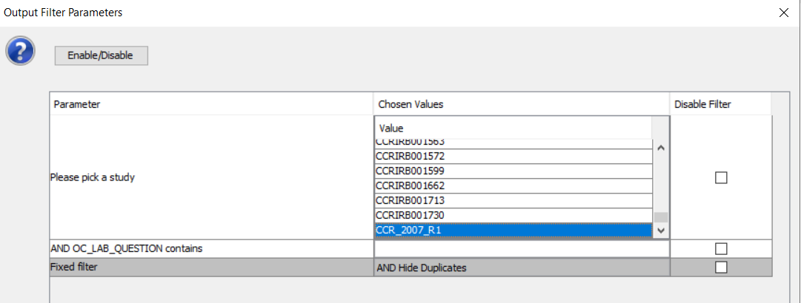
Below is a sample report, report has the following columns:
- STUDY
- SUBJECT
- LABTEST_NAME
- TEST_CODE
- OC_LAB_QUESTION
- OC_LAB_SUBSET
- RESULT
- UNIT
- NORMAL_VALUE
- SAMPLE_DATE
- SAMPLE_TIME
- ERROR_REASON
- LABORATORY
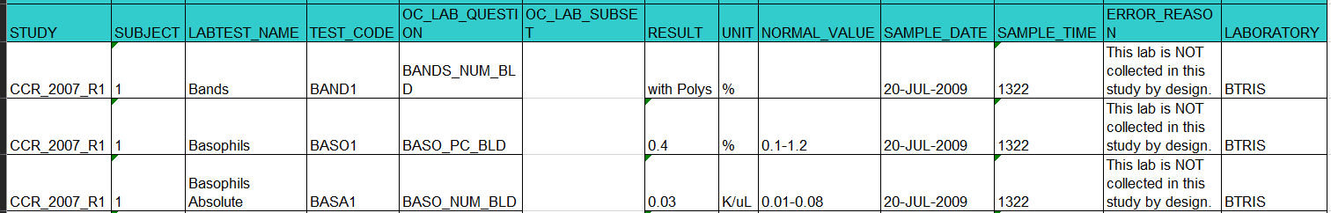

Study Specific Reports folder
CR AE/SAE Count Report
CR AE/SAE shows the total number of all Adverse Events and the total number of Serious Adverse Events collected in the Adverse Event form in the study.
Below is a sample report, report has the following columns:
- # of AEs (AE Count)
- # of Serious AEs (SAE Count)
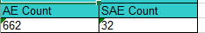

CR Report
CR Report shows the number of events related to Research since Last CR Reporting and # of Events related to Research since Study Start, which are grouped by grouped by SOC, CTCAE Term, AE Description, Grade, Attribution to Research, Serious, Unexpected. It requires two parameters to be entered: Previous Cutoff Date and Current Cutoff Date.
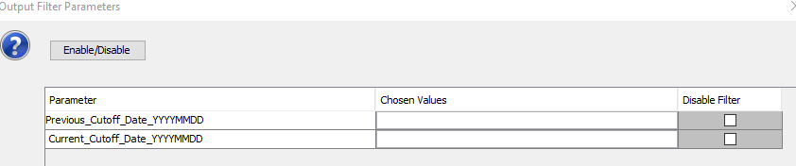
Below is a sample report, report has the following columns:
- SOC
- AE Term
- Description
- Grade
- Unexpected
- Serious
- # Events Since Last Report
- # Events Since Study Start
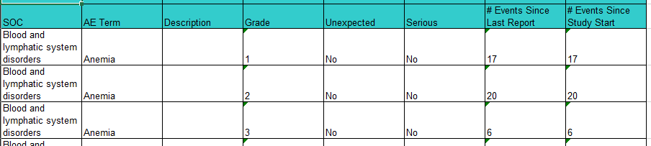

Template Reports folder
AE Data Listing Report
AE Data Listing Report lists out all columns in Adverse Event form. All active data will be included in the report. It accepts two parameters: Subject and Current cutoff date.
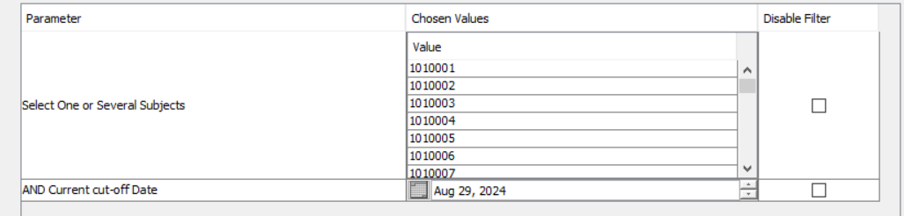
Below is a sample report, report has the following columns:
- Study
- Site
- Subject
- Date of Onset
- Date of Resolved
- CTCAE Term (5.0)
- Adverse Event Description
- Grade
- Grade (Coded Value)
- Attribution to Research
- Attribution to IND
- Attribution to Disease
- Attribution to Other
- Other Specify
- Unexpected AE
- Therapy
- Expedited Report to IRB

Arm and Cohort Assignment Report
Armand Cohort Assignment Report shows the Arm and cohort information of all subjects in the study.
Below is a sample report, report has the following columns:
- Study
- Site
- Subject
- Log Line
- Date
- Cohort Name
- Cohort Description
- Arm Name
- Arm Description
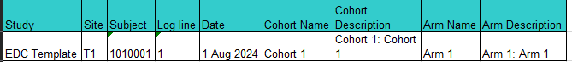

Baseline Symptom Report
Baseline Symptom Report shows all columns in Baseline Symptom form. All active data will be included in the report.
Below is a sample report, report has the following columns:
- Clinical Study
- Subject
- Onset Date
- Date Resolved
- CTCAE Term (5.0)
- SOC
- Symptom Description
- Grade
- Related to Disease
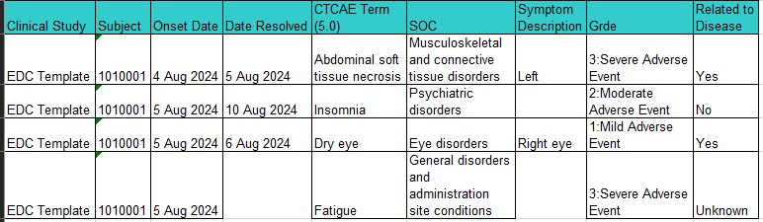

Enrollment Report
Enrollment Report shows all columns in the Enrollment form. All active data will be included in the report.
Below is a sample report, report has the following columns:
- Study
- Site
- Subject
- Lesion anatomic site description
- Date of Diagnosis
- Histology
- Grade of Histology
- Dose Level
- Disease stage at entry
- Gleason Score
- T Stage
- N Stage
- M Stage
- Date of Confirmation Histology
- Date of Informed Consent Version
- Date from which to start including labs
- Collected?
- Collection Date
- Comments

Follow Up Report
Follow Up report shows all columns in the Follow Up form. All active data will be included in the report.
Below is a sample report, report has the following columns:
- Study
- Patient
- Actual Visit (Folder)
- Date of Last Contact
- Type of Contact
- Received Treatment Since Last Contact
- Patient Status
- Explain ‘Unknown’ Patient Status
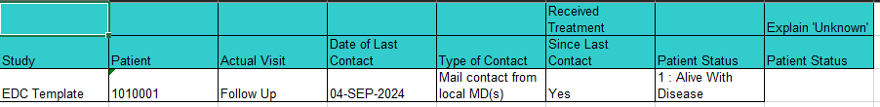

Off Treatment/Off Study Report
Off Treatment/Off Study Report shows the Off Treatment/Off Study Date and Reason and other information collected in the two forms.
Below is a sample report, report has the following columns:
- Study
- Patient
- Date Off Treatment
- Reason Off Treatment
- Date of Last Medication Administration
- Best Response to Treatment
- Date of Best Response
- Date of Disease Progression
- Date Off Study
- Reason Off Study
- Date of Disease Progression

Subject Enrollment Report
Subject Enrollment Report shows all columns in the Subject Enrollment form. All active data will be included in the report.
Below is a sample report, report has the following columns:
- Subject
- Site
- Is the subject eligible?
- Date of Birth
- Age at entry
- Subject’s Initials
- Race
- Ethnicity
- Disease Term
- Registering Institute
- Registering Institute Description
- Date Informed Consent Signed

Course Summary Plus RECIST Report
Course Summary Plus RECIST Report shows columns from Arm/Cohort, Course Initiation, Course Assessment, Disease Assessment RECIST forms. All active data will be included in the report.
Course Summary Plus RECIST Report shows columns from Arm/Cohort, Course Initiation, Course Assessment, Disease Assessment RECIST forms. All active data will be included in the report.
Below is a sample report, report has the following columns:
- Study
- Patient
- Visit
- Course #
- Start Date of Course
- Stop Date of Course
- Arm
- Dose Level – CINI
- Dose Level - ENRL
- Treating Institution
- Dose Change
- Course Disposition
- Any Adverse Events in this Course?
- Any concomitant medications taken in this course?
- irRC Response
- Date of Response
- Date of Progression
- Sum of Diameters
- Targeted Lesion Baseline Sum
- Smallest Sum of Longest Diameters of all
- % Change from Best Response
- % Change from Baseline
- Targeted lesion response
- Non-targeted lesion response
- New Lesion?
- Overall Response
- Overall Response Duration
- Best Overall Response

Extent of Disease Report
Extent of Disease Report shows columns from Extent of Disease Lesion Identification and Lesion Measurement forms. All active data will be included in the report.
Below is a sample report, report has the following columns:
- Study
- Patient
- Lesions #
- Anatomic Site
- Description of Location
- Description of Lesion
- Previously Irradiated
- Course #
- Day in Course
- Date of Evaluation
- How Measured
- Measurement (First Longest)
- Measurement (Second Longest)
- Measurement (Third Longest)
- Product
- Total Tumor Volume
- Eval #
- Eval Code
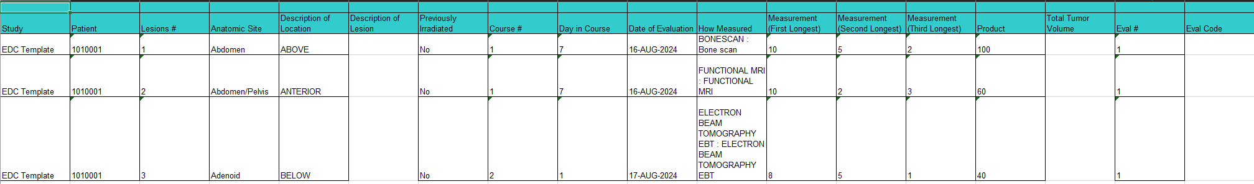

Study Drug Administration Report
Study Drug Administration Report is developed for studies that were migrated from C3D, which study drug administration and study drug missed are built in separate forms. This report shows patient initials and all columns in the Study Med Admin form. All active data will be included in the report.
Below is a sample report, report has the following columns:
- Study
- Patient
- Initials
- Visit
- Day in Course Start Date
- Start Date
- Start Time
- Stop Date
- Stop Time
- Medication
- Dose Level
- Dose UOM
- Schedule
- Route
- Actual Dose
- Actual UOM
- Duration
- Duration UOM

Study Drug Administration/Missed Combined Report (To be Developed)
Study Drug Administration/Missed Combined Report is developed for studies that have study drug administration and study drug missed combined in one form. This report shows patient initials and all columns in the Study Med Admin/Missed form. All active data will be included in the report.

