J-Review can be used with Internet Explorer and Firefox on Windows 7. On a Mac, use Firefox. Do not use Safari or Google Chrome.

Login:
On the following page (official login page), click on the Launch button:
https://octrials-rpt.nci.nih.gov/
On the following page (alternate login page), click on the Log into J-Review button:
https://ccrod.cancer.gov/confluence/display/CCRClinicalIT3/Login
You might see the following prompt when using Firefox. Make sure Open with Java Web Start Launcher is selected and click OK.
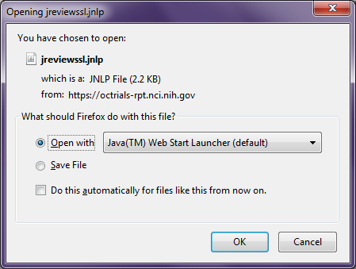
Java will start and display its version (Java Runtime version 7 and 8 are also supported).


After the version is displayed, a few J-Review files are downloaded and the login page displayed.
Enter your C3D account and password, ncidb-p120:ocprod for both Database and SAS Server. Click OK to login.
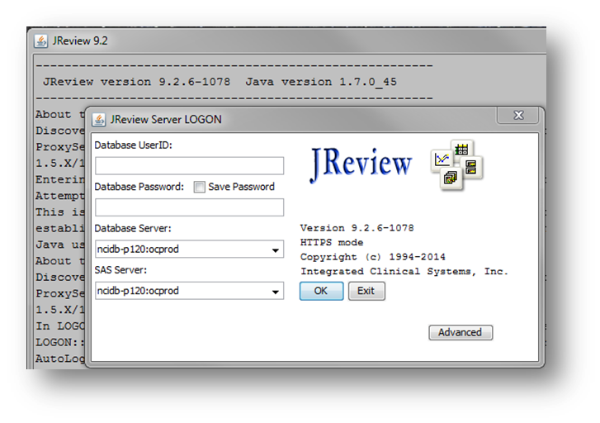
If your login attempt fails, it is either because you entered the incorrect user name, password or database server and you will see the following message.
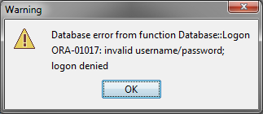

Or if your C3D account password is about to expire, you will see this message and won't be able to log into JReview until you change the password.
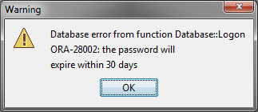

If you encounter problems logging into J-Review, please contact the C3D Help Desk at 240-276-5541 or via e-mail ncicbiit@mail.nih.gov

